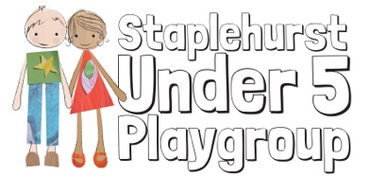
Registered Charity No. 802551

RISK ASSESSMENT POLICY

Staplehurst Under 5 Playgroup believes that the health and safety of children is of paramount importance. We aim to ensure that our setting is a safe and healthy place for children, parents, staff and volunteers by assessing and minimising risks and hazards, thus enabling children to thrive in a healthy and safe environment.

Procedures

Our risk assessment process covers adults and children, activities and equipment, and both indoor and outdoor spaces.
- Our indoor and outdoor equipment is checked daily for cleanliness and safety. If equipment is in need of attention, it is removed and an action plan put into place to assess whether to repair or discard. The time-scale for action and any funding required is set.
- Our indoor premises are checked daily for security, safety and cleanliness, and a safety check sheet is completed, signed and dated.
- Our outdoor spaces are checked daily for cleanliness. The outside fence is checked for security before use, and an outdoor safety check sheet is completed, signed and dated.
- Our current resources and premises audit is situated in the locked cupboard, Main Hall.

