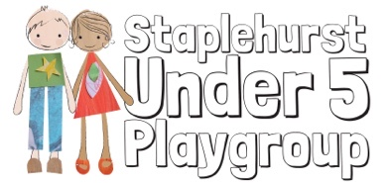
Registered Charity No. 802551
BULLYING POLICY
We take bullying very seriously. Bullying involves the persistent physical or verbal abuse of another child or children.
If a child bullies another child or children:
- We show the children who have been bullied that we are able to listen to their concerns and act upon them.
- We intervene to stop the child who is bullying from harming the other child or children.
- We explain to the child carrying out the bullying why their behaviour is unacceptable.
- We give reassurance to the child or children who have been bullied.
- We help the child who has carried out the bullying to recognise the impact of their actions.
- We do not label children who bully as ‘bullies’.
- We recognise that children who bully may be experiencing bullying themselves, or be subject to abuse or other circumstances causing them to express their anger in negative ways towards others.
- We discuss in confidence what has happened with the parents of the child who carried out the bullying, and work with them to plan a solution for handling the child’s behaviour.
- We share in confidence what has happened with the parents of the child who has been bullied, explaining that the child who carried out the bullying is being helped to adopt more acceptable ways of behaving.

